Nama : Dwi Febi Fauzi

NIM : 18090125

Kelas : 5C

1. URL : <http://localhost/ci_fauzi/index.php/perkenalan>
2. Source Code

* application 🡪 controller 🡪 perkenalan.php

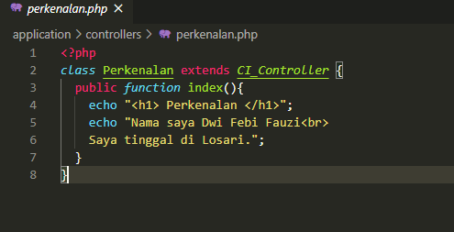

1. Screen Shoot

